

**MAEER’s ARTS, COMMERCE AND SCIENCE COLLEGE PUNE**

A Project Report on

**“Online Furniture Management”**

Submitted by,

Bhushan Sakhalkar

Ajinkya Gadhave

And

Siddhant Bhoir

Under the guidance of

Mrs. Archana Varade

Submitted by the partial fulfilment

Of

**Bachelor of Computer Science**

**Savitribai Phule Pune University**

For Academic Year

**2018-2019**



**MAEER’s ARTS, COMMERCE & SCIENCE COLLEGE, PUNE**

(Accredited by NAAC with ‘A’ Grade)

**Department of Computer Science**

**CERTIFICATE**

This is to certify that Mr. **Bhushan Sakhalkar** of Bachelor in Computer Science, **Seat nos. C-643** has successfully completed Project titled **“Online Furniture Management”** in PHP/JAVA Programming for the academic year **2018-2019**.

**(Internal Guide) Head, Dept. of Computer Science**

**B.Sc.(C.S)**

**Mrs Archana Varade Mr. Jayant Patil**

**Principal**

**Date:**

Examiner:

1.

2.

**Acknowledgement**

All successful completion of the project, looking back our development efforts we found so many people who helped, supported and guided us to complete this project.

We would sincerely like to thank our guide **“Mrs. Sapana Singh”** for their sincere guidance, timely help and valuable suggestion without which his project would not have been possible. We would also like to thank the head of department “**Mr. C.H. Patil ”** our class teacher “**Mrs.Archana Varade ”** and staff for their co-operation and help in completion of this project.

**INDEX**

|  |  |  |
| --- | --- | --- |
| **Sr No.** | **TITLE** | **Page No.** |
| **1.** | **Introduction** | **5** |
| **2.** | **Existing System** | **6** |
| **3.** | **Scope of work** | **7** |
| **4.** | **Feasibility Study** | **8** |
| **5.** | **Need for the system** | **9** |
| **6.** | **Requirement Analysis** | **10** |
| **7.** | **Operating Environment** | **10** |
| **8.** | **Proposed System** | **11** |
| **9.** | **Objectives** | **11** |
| **10.** | **Data Dictionary** | **12** |
| **11.** | **Diagrams** | **14** |
| **12.** | **Input/Output Screens** | **21** |
| **13.** | **Testing** | **37** |
| **14.** | **Advantages and Disadvantages** | **38** |
| **16.** | **Future Enhancements** | **40** |
| **17.** | **Bibliography** | **41** |

**Introduction**

I have been given the task to develop a Linux based application for a very interesting topic viz. Furniture Management. I chose a combination of php JavaScript and html CSS to develop this application. Nowadays, no one wishes to neither has the time to go out to select furniture also the sites already in existence are intermediaries and hence this application. This application helps the owner of any store to bring their products at the customer’s doorstep and the customer can view select and order anything at any time from any place. My first step in this entire process was to analyse the basic needs of any customer and seller in such situations. Once I studied all the aspects for the project which includes the basic requirements, feasibility, I came up with a basic idea of what my project was going to look like.

The analysis was then followed by the creation of a relevant database. Once the database was finalised, the next and one of the most essential part of this entire project which is coding, followed by the implementation of the functionalities.

I have followed the iterative waterfall model for development of the web application. Then I have tested the web application under various environmental conditions.

**Existing System**

There is no such existing web application without any intermediaries which helps the owner sell products to the customer who can buy them setting at home from any shop anywhere in this world. The prevailing applications are all intermediaries which take a huge commission from every order hence either unsatisfying the customer by selling the products at a very high price or the seller by reducing his profits by a high margin. And the small shops which cannot pay such high commissions aren’t even represented on such intermediaries’ sites. Most of such shops still have manual systems to store the customer information as well as to record the data and orders.

The existing system does not include soft copies of the bills, but has paper bills. The billing system is very outdated resulting in tedious extra work for the institutions. The only purpose of the existing system is to help customer buy the products every shop has to sell without them being actually present and without any intermediaries meddling in the business. The entire process is handled by the application right from storing the information to generating bills from the customer’s perspective and from adding information viewing the order details to updating the products can be done by the application on the owner’s/seller’s side.

The existing systems have to store everything manually and have to even do all the calculations and every bit of work manually increasing the unrequired human efforts. Hence the existing system’s method stands outdated in the current modern era.

**Scope of Work**

The Furniture Management System provides following scopes:

* Owing to this system, all the small shops can have their own platform just a click away.
* It is instrumental in storing all the important details of the customers and the products securely in the database and can also be retrieved as per the requirements.
* The application generates a bill copy whenever any customer places some order as well as decrements the quantity of that particular product.
* The details of the customer viz. address, name ,amount,bill id,etc is also recorded for further use.
* The application provides different categories viz. Sofa bed and Table for proper segregation.
* The application also has a price filter as well as a search bar to reduce the customer’s efforts.

**Feasibility Study**

Feasibility study is an essential part of any web application development process. It ensure the credibility of our application in the real world. This study is further divided into the following two parts:

Operational Feasibility:

Basic information needs to be entered only once.

Faster processing of data to give proper output.

Hence, the proposed system is operationally feasible.

Technical Feasilibility:

The minimum requirements for effective and efficient working of the software are as follows:

* LINUX UBUNTO Operating System
* 2GB RAM
* Postgresql
* Xampp Apache
* HTML5

Considering today’s software and hardware trends, the proposed system is technically feasible.

**Need for the System**

Nowadays, time factor is given much more priority than any other aspect we are living with. Computerization comes in handy to reduce our time consumption.

The need for the proposed system is:

* To provide the customers easy and hassle free access to all the nearby shops at the click of a button.
* We can get more information in less time.
* Need to understand how to store all the details of the products and the customer.
* It is required to keep a track of all the previous transactions for the customer, to store the payment history of all the finished transactions.
* Paper-free bill generation and maintaining the records of all the products sold and the amount charged for the same.

Use of the Furniture Managemnet System supports the concept of “Paperless Office”.

Requirement Analysis:

* For our project we require all the basic needs such as a Computer with LINUX operating system .
* For our system to work all we need is a browser , and that computer should be connected to server machine.
* On the server machine our system needs Java servlet on the front end and PostGre SQL on the back end.
* Once all these things are done then we can load our system on any machine that is connected to that server machine.

**Operating Environment:**

Hardware Requirements:

The hardware used for the proposed system is:

* 17” Monitor
* RAM min 2GB
* Hard Disk 160GB

Software Requirements:

The software used for the proposed system is:

* LINUX UBUNTU Operating System
* Xampp Apache
* HTML5
* Postgresql

**Proposed System**

The advantages provided by the proposed system which is Furniture Management System are:

* Paperless office
* Prompt Services
* Reduction of man power
* Modern technical environment
* Help in designing the future plans
* Useful in development and growth
* Increased speed of work.

In this way the proposed system will help to store details of products without any difficulties and overcome all the problems of the current manual system.

**Objectives**

* On the basis of this system, it should be easy to recognize the active processing of the system.
* Able to easily manage the system and the contents of the system.
* Using this system, display of the products can be done easily.
* Storing the details of the freshly registered users and products as well as the existing ones can be done easily as it is very user-friendly.
* A bill is easily and uniquely generated for each transaction which is automatically sent to the concerned customer and the bill details to the concerned seller.
* Paperless bill generation and the ability to view your previous interactions and the total amount of the interactions.
* Updations and new insertions reflect in the application within no time.
* Cart can be viewed at any time,items can be added and deleted from the cart.
* User can log in and logout and hence this system keeps your product viewing and cart details disclosed from other people.

**Data Dictionary**

**Customer Table**

|  |  |  |  |
| --- | --- | --- | --- |
| **Field Name** | **Description** | **Data Type** | **Constraint** |
| Username | Customer email | Varchar(100) | Primary Key |
| Fname | Customer first name | Varchar(100) | No Constraints |
| Lname | Customer last name | Varchar(100) | No Constraints |
| Mobile | Contact no | Numeric | No Constraints |
| Address | Customer address | Varchar(100) | No Constraints |
| Password | Password | Varchar(100) | No Constraints |

**Product Table**

|  |  |  |  |
| --- | --- | --- | --- |
| **Field Name** | **Description** | **Data Type** | **Constraint** |
| Pid | Product Id | Varchar(100) | Primary Key |
| Pname | Product name | Varchar(100) | No Constraints |
| Pprice | Product Price | Numeric | No Constraints |
| Pimg | Product Image | Varchar(100) | No Constraints |
| PDescription | Product Description | Varchar(100) | No Constraints |
| Quantity | Product Quantity | Varchar(100) | No Constraints |

**Admin** **table**

|  |  |  |  |
| --- | --- | --- | --- |
| **Field Name** | **Description** | **Data Type** | **Constraint** |
| AUsername | Admin email | Varchar(100) | No Constriants |
| Aname | Admin name | Varchar(100) | No Constriants |
| ADesignation | Admin Designation | Varchar(100) | No Constriants |
| Aid | Admin id | Integer(Serial) | Primary Key |
| APassword | Password | Varchar(10) | No Constriants |

**Bill Table**

|  |  |  |  |
| --- | --- | --- | --- |
| **Field Name** | **Description** | **DataType** | **Constraint** |
| Pid | Bill No | Serial | Foreign Key |
| Price | Product Price | Numeric | No Constraints |
| Username | Customer email | Varchar(100) | Foreign Key |
| Date | Date of order | Varchar(40) | No Constraints |

**Cart Table**

|  |  |  |  |
| --- | --- | --- | --- |
| **Field Name** | **Description** | **Data Type** | **Constraint** |
| Pid | Product Id | Varchar(100) | Foreign Key |
| Username | Customer email | Varchar(100) | Foreign Key |

**Entity Relationship Diagram**

buys

**Customer**

**Product**

Stores

adds

controls

pays

**Cart**

has

**Admin**

monitors

**Bill**

**Data Flow Diagram**

**Level 0:**

**Admin**

**Insert Product Details Delete,Update Product**

**Bill Details**

**0.0**

**Furniture Management**

**Registration details pays bill**

**Username & password**

**Product View**

**Generate bill**

**User**

**Level 1:**

1.0

Add Products

**Admin**

Products

2.0

Update Products

Customer

**Customer**

3.0

Customer Details

4.0

View Products

Cart

5.0

Add To Cart

Bill

6.0

Place Order

7.0

Generate Bill

Bill

**UML Diagrams**

**Class Diagram**

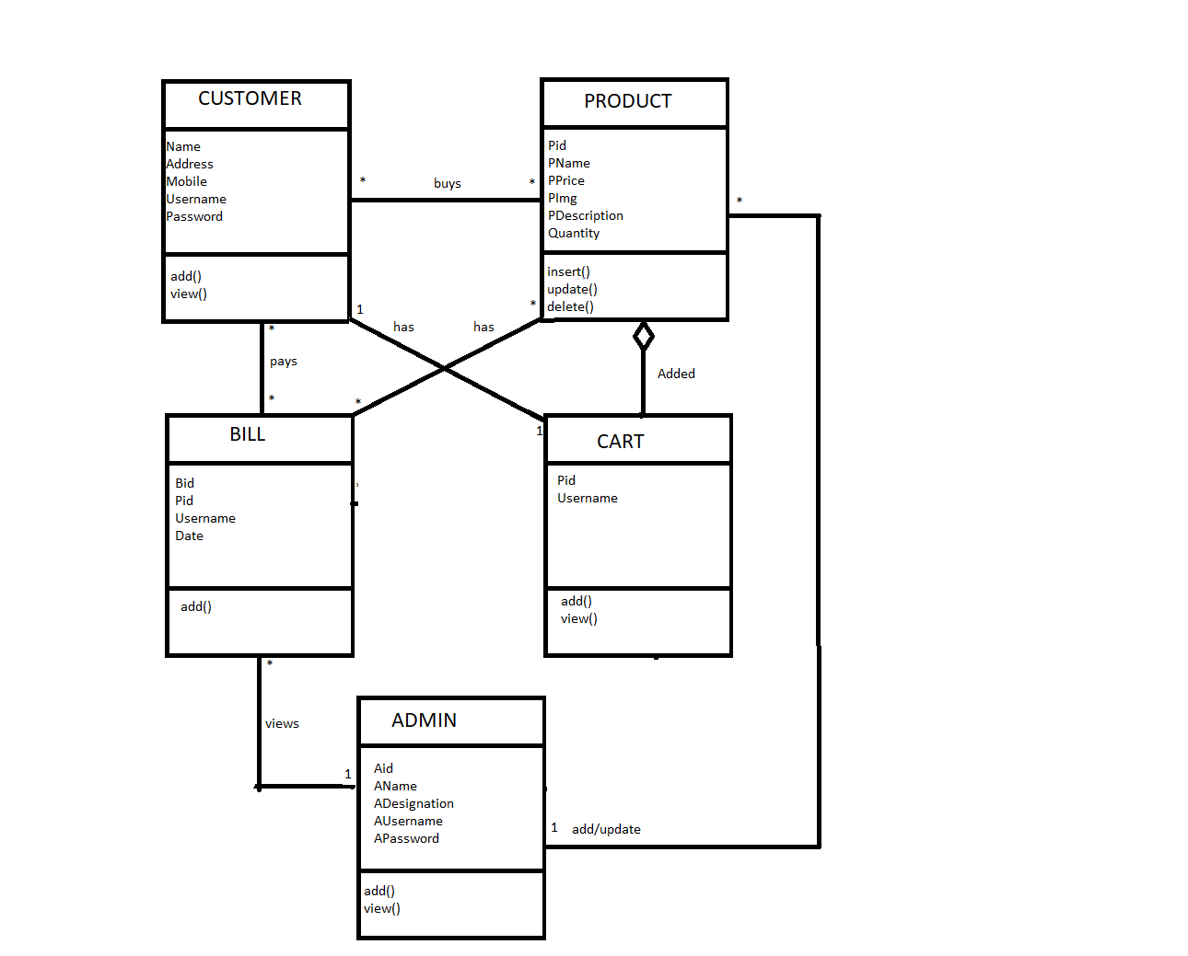

**Activity Diagram**

**For Admin**

**Start**

**Logged in?**

No

**Login**

Yes

**Update**

**Insert**

**Delete**

**View Order Details**

**End**

**For User**

**Start**

**Registered?**

No

**Register**

Yes

**Add to cart**

**View Product**

**Place order**

**Search**

**Remove from cart**

**End**

**Use Case Diagram**

**Admin**

**Customer**

**Sequence Diagram**

**System**

**Database**

**Log In**

**Log in**

**Admin**

**Customer**

**Update Products**



**Insert Products**

**Customer details**



**Check availability**

**View Products**

**Add to cart**

**Add Products to Cart**

**Acknowledgement**

**View Cart**

**View Cart**

**Cart Details**

**Generate bill**

**Add to bill**

**Place Order**

**Bill details**

**View Bill**

**Bill Details**

**HOME PAGE**

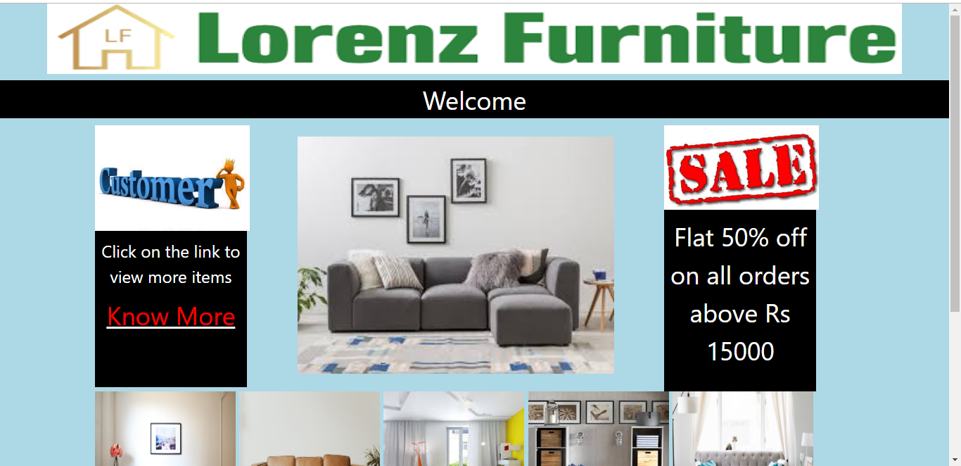

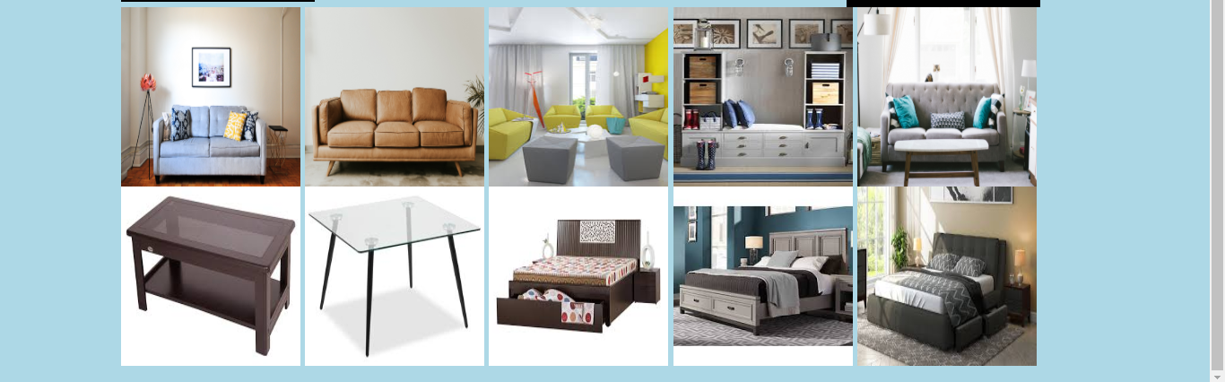

**LOGIN PAGE**

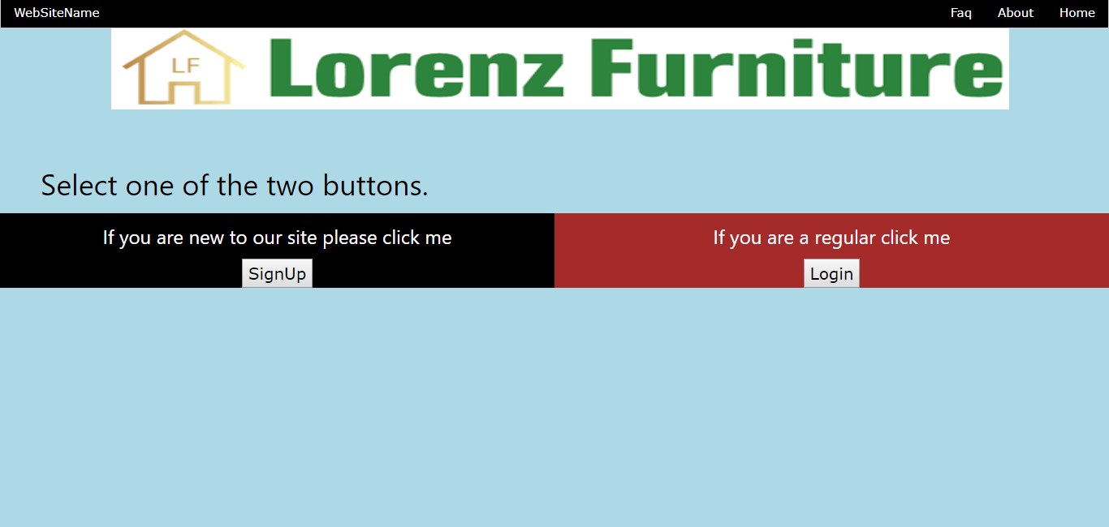

**Signup**

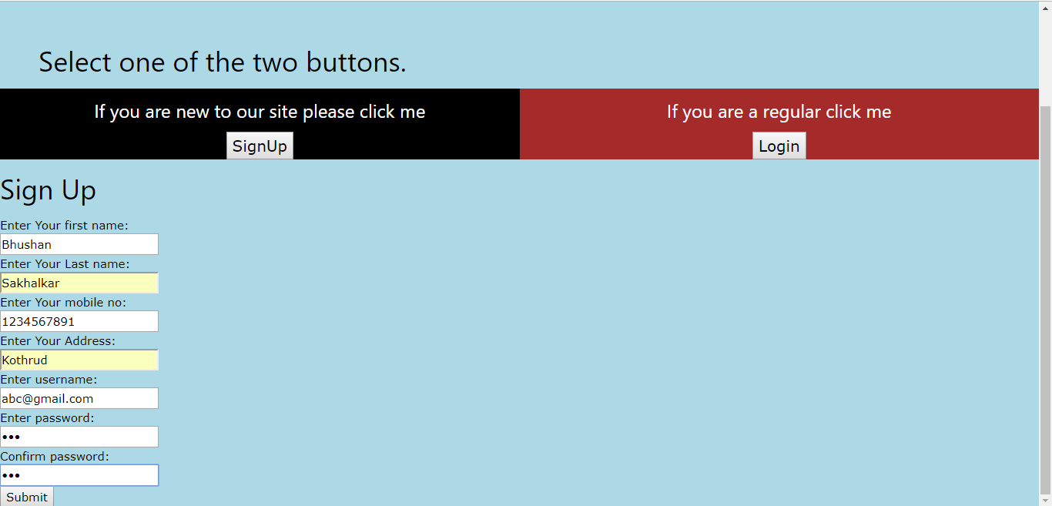

**Validation**

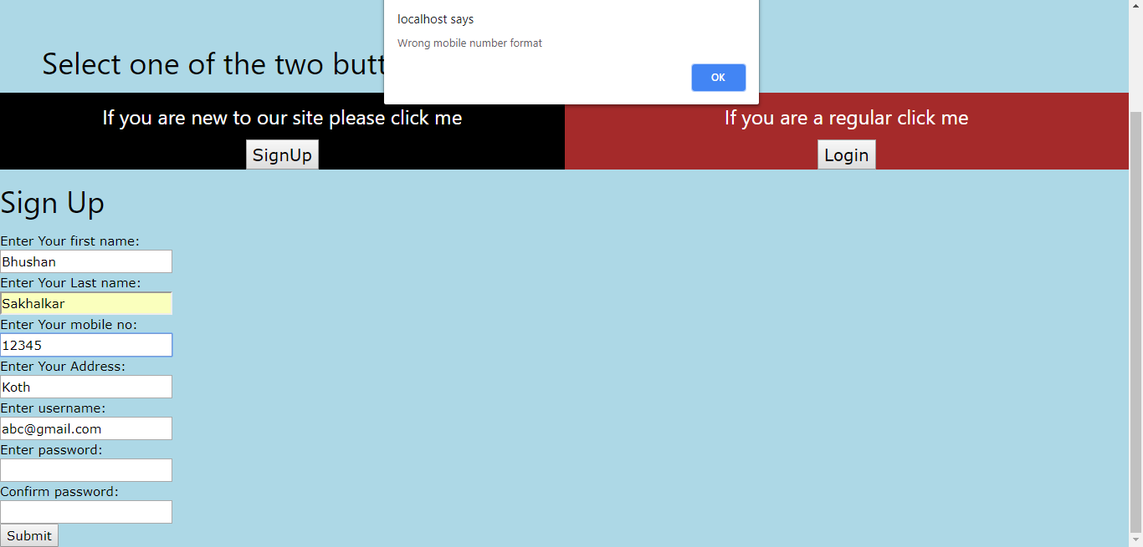

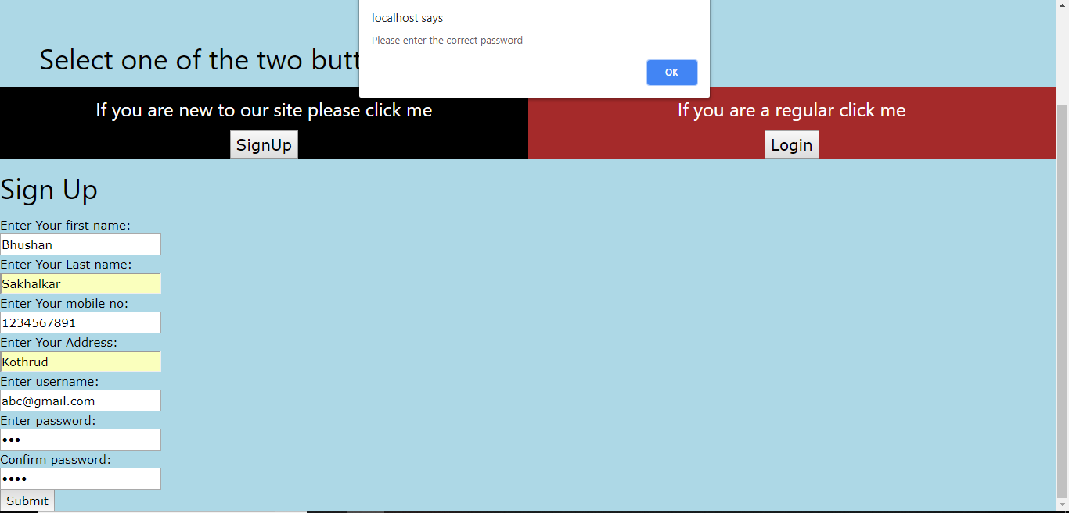

**Login**

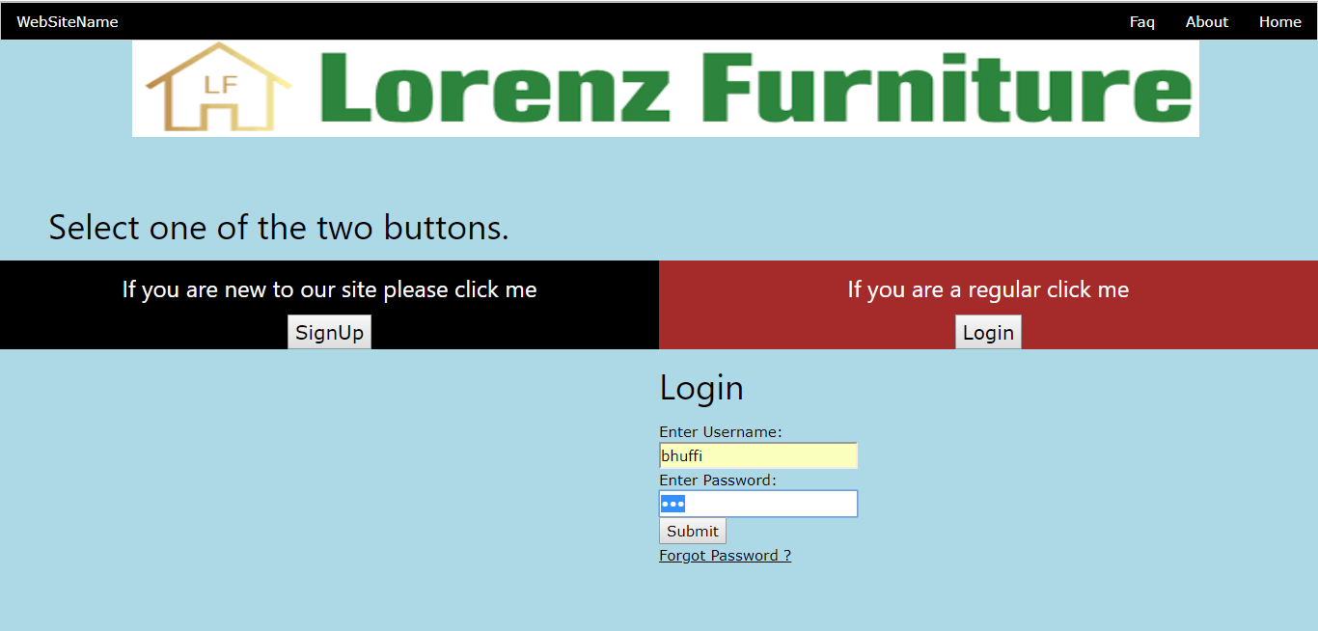

**WELCOME PAGE**

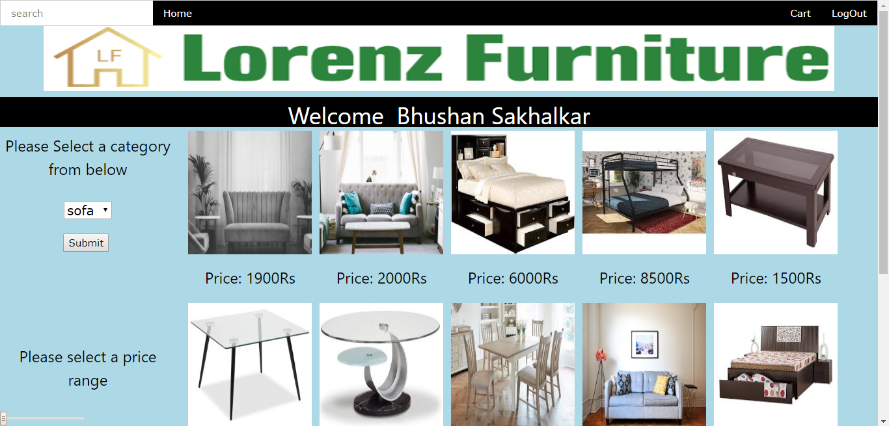

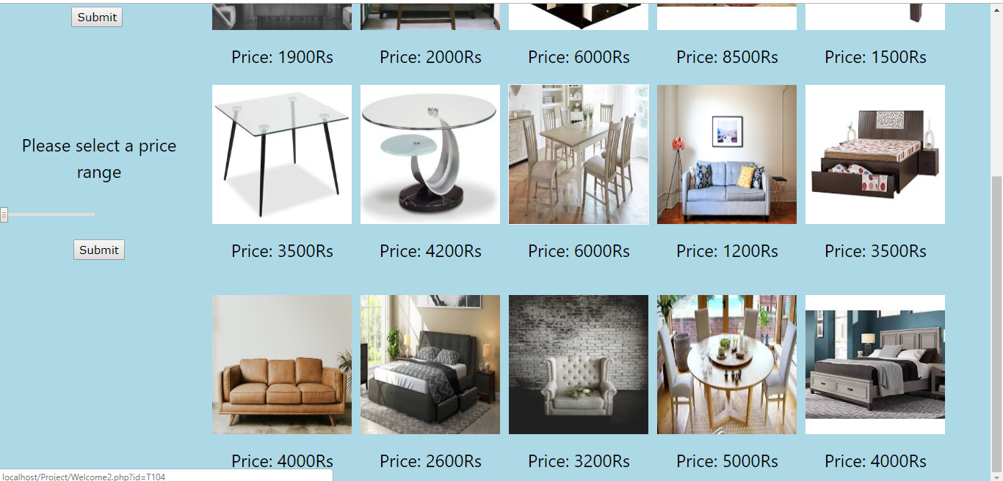

**SEARCH BAR**

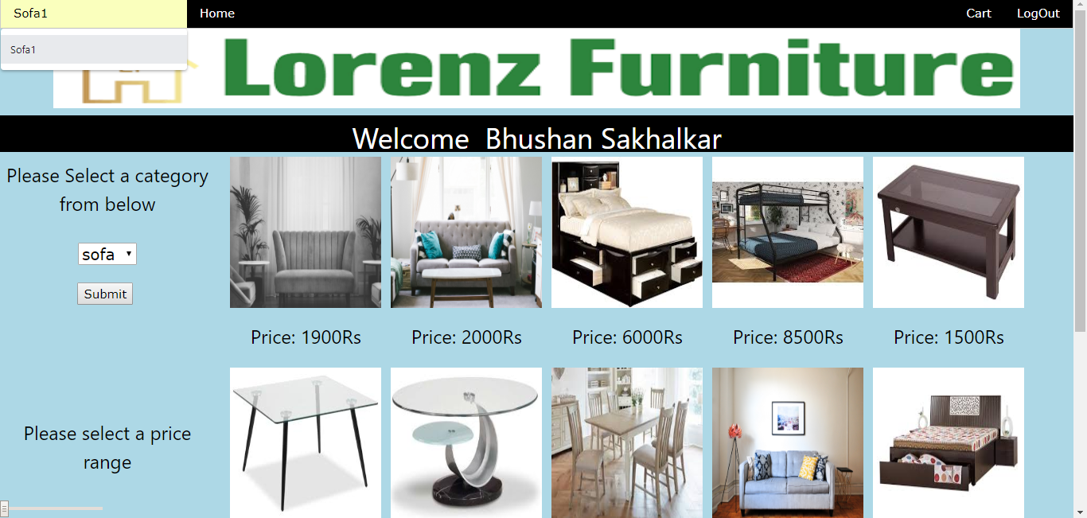

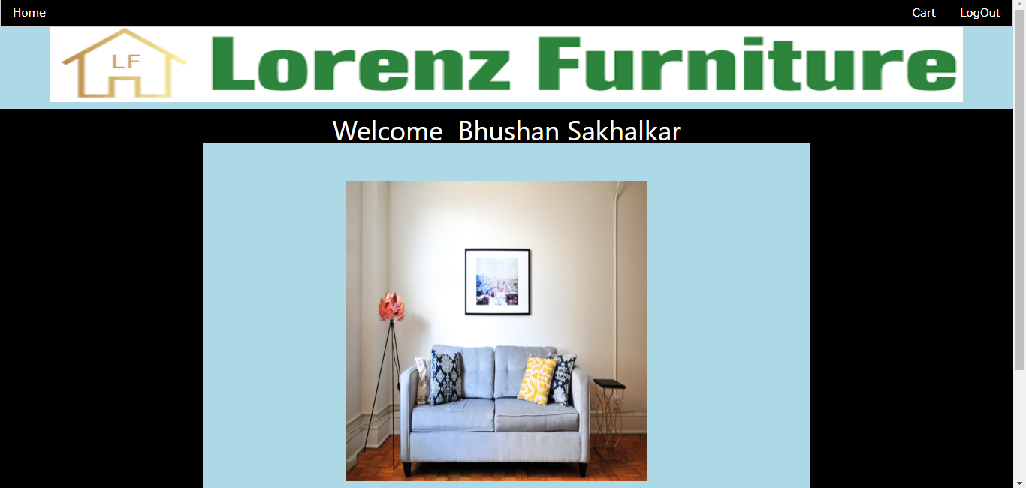



**CATEGORY FILTER**

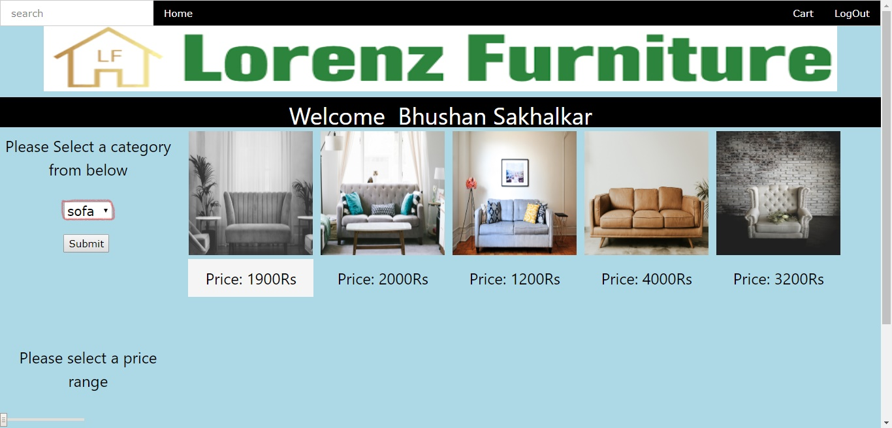

**PRICE FILTER**

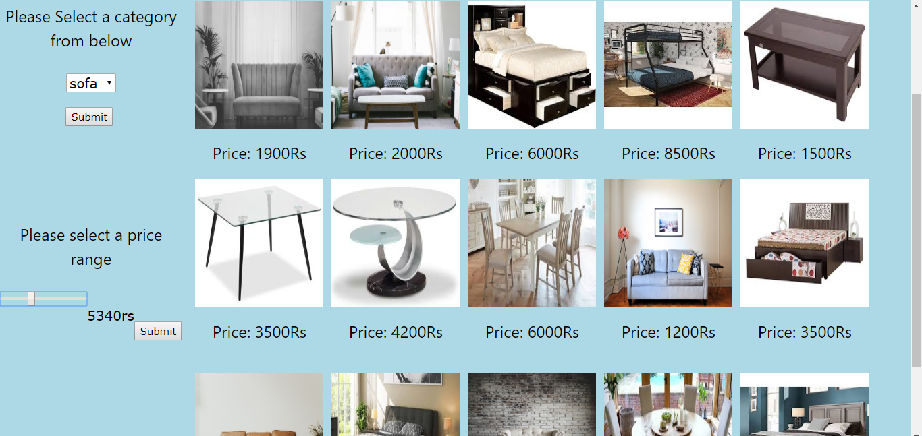

**Product Page**

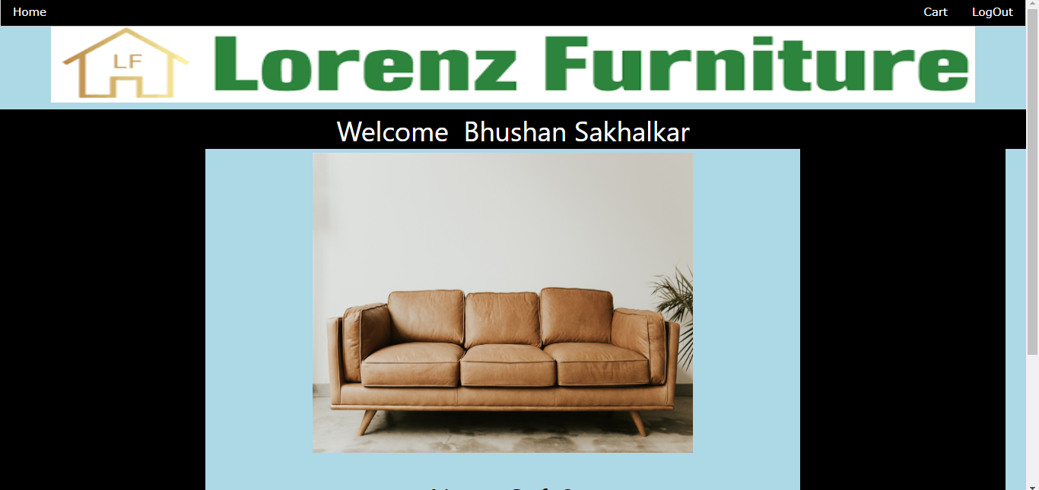



**ADD TO CART**

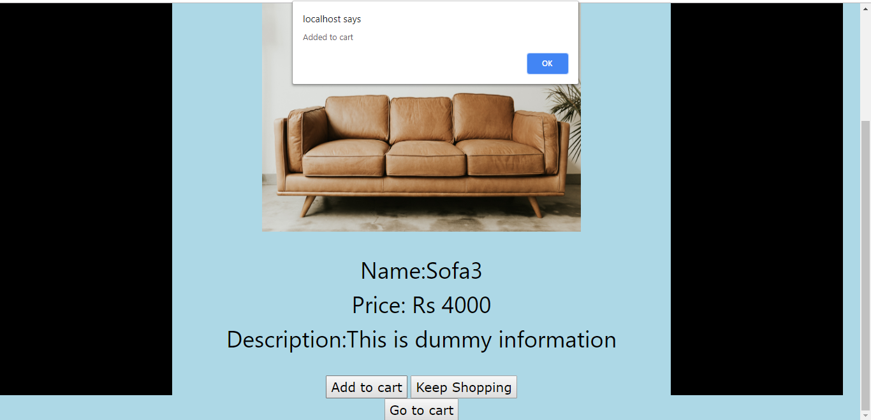

**PRODUCT UNAVAILABLE**

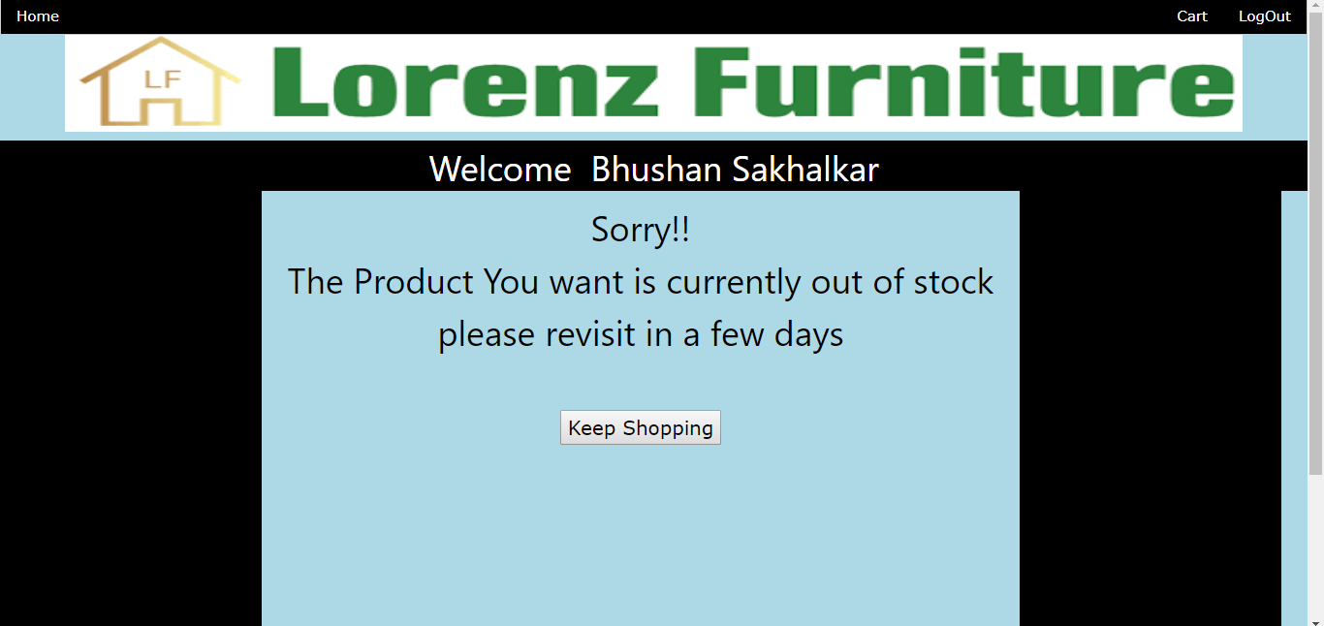

**CART**

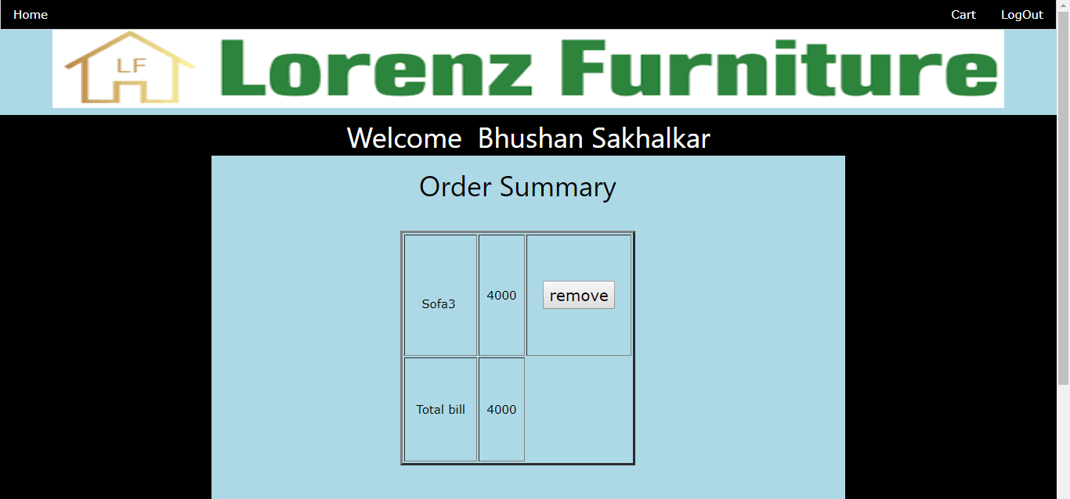



**PROCEED FOR PAYMENT**

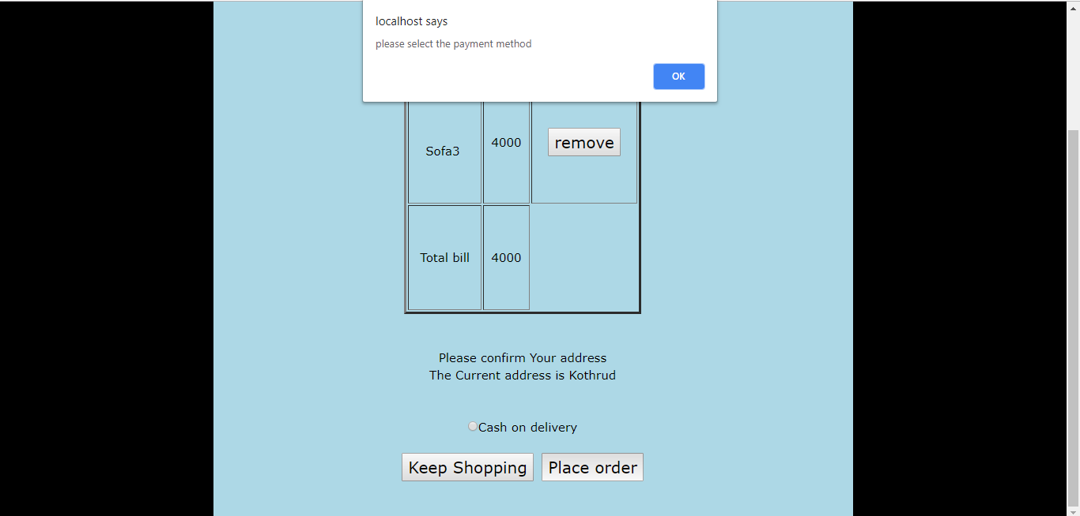

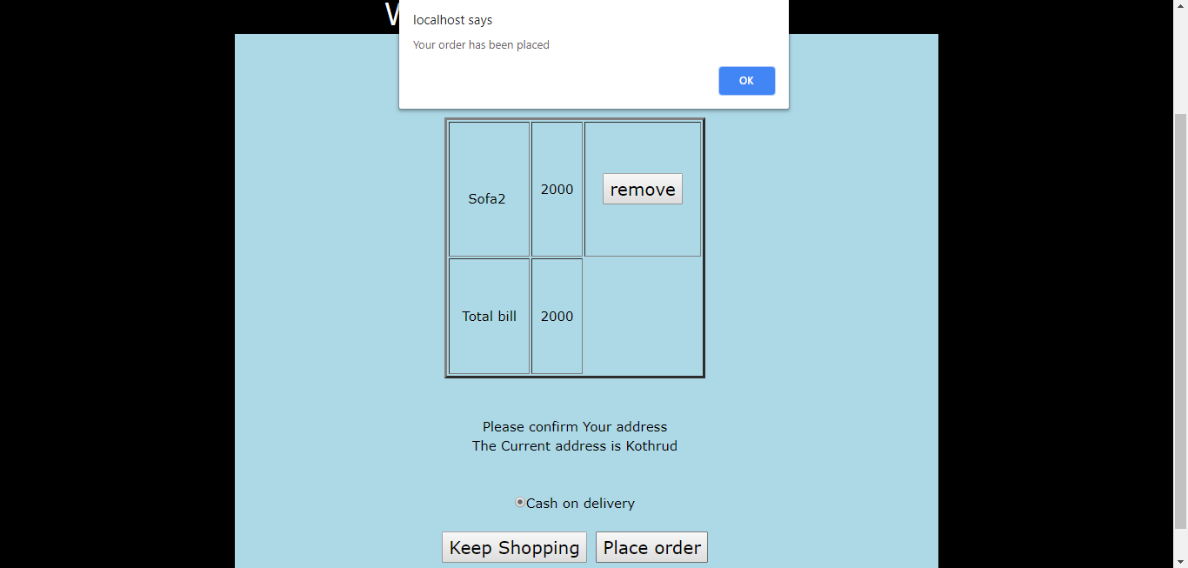

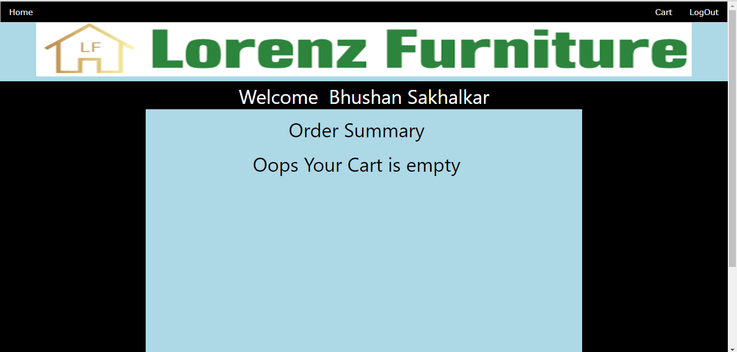

**LOGOUT**

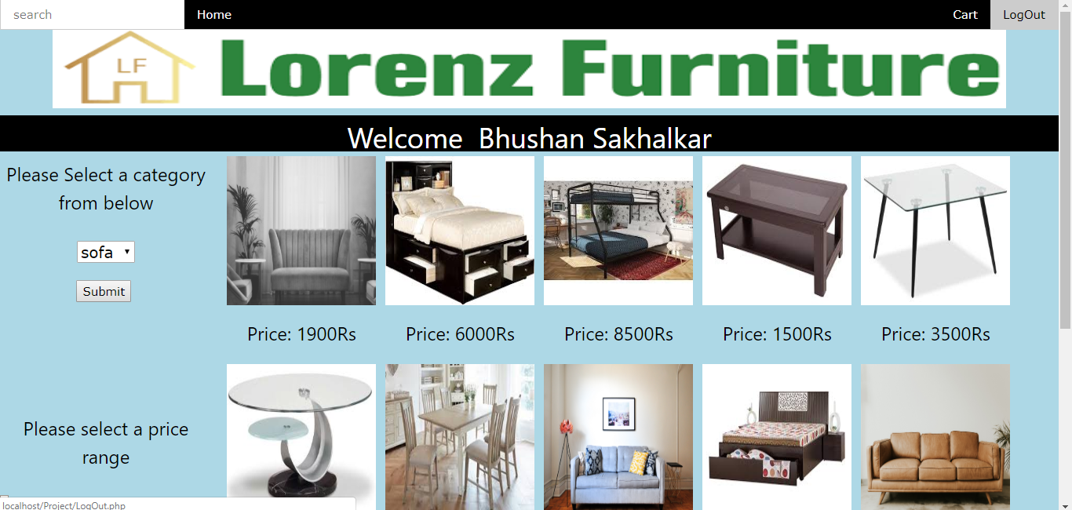

**ADMIN LOGIN**

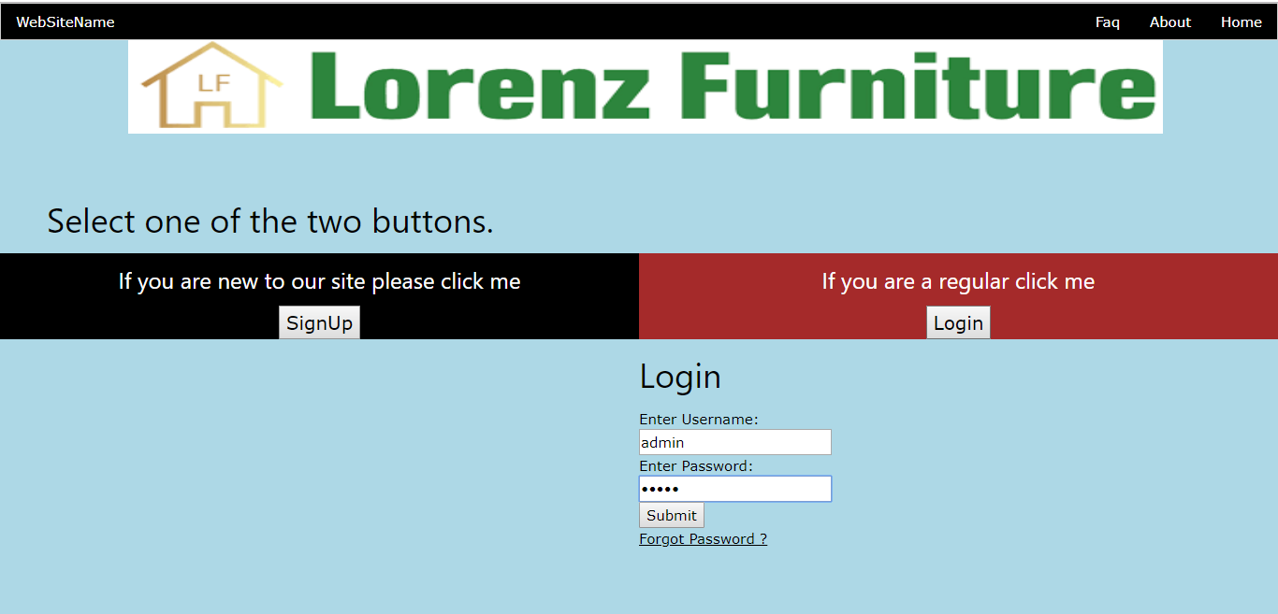

**ADMIN MAIN PAGE**

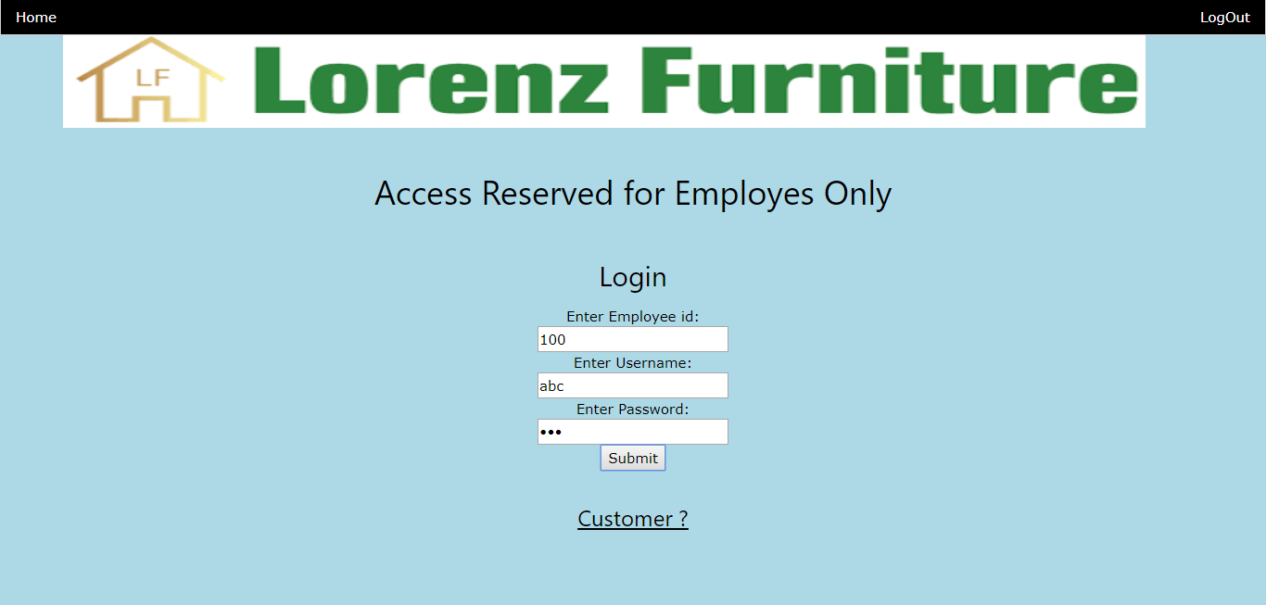

**ADMIN WELCOME PAGE**

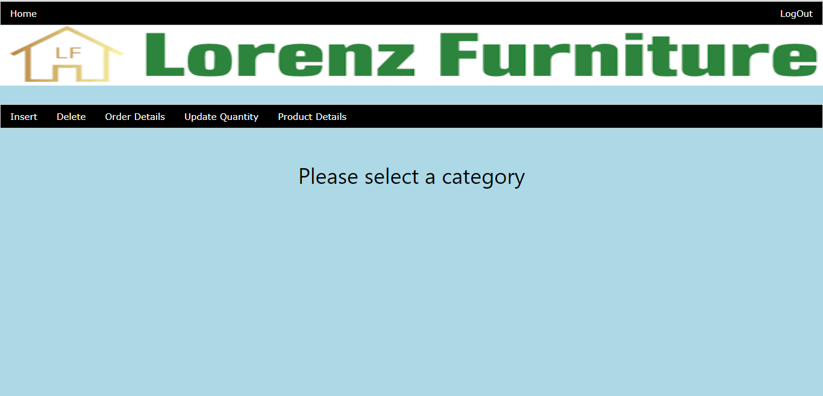

**INSERT**

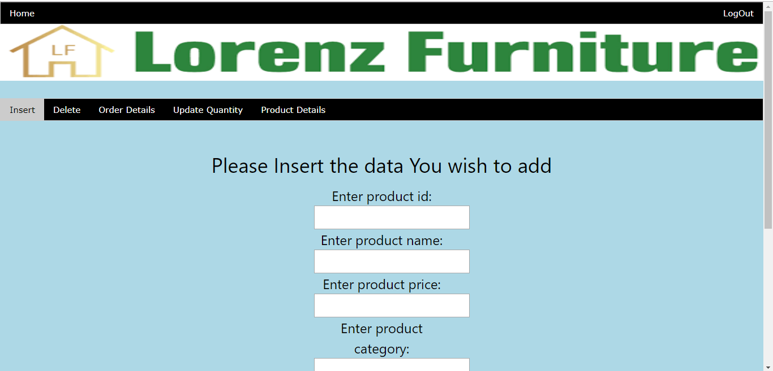



**DELETE**

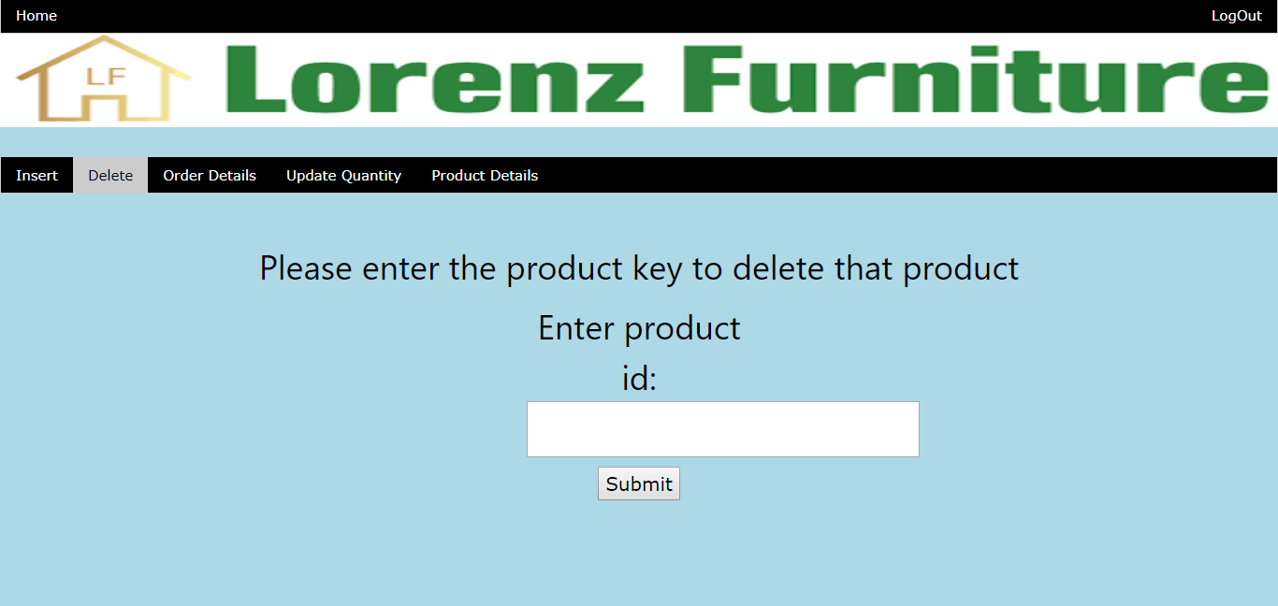

**ORDER DETAILS**

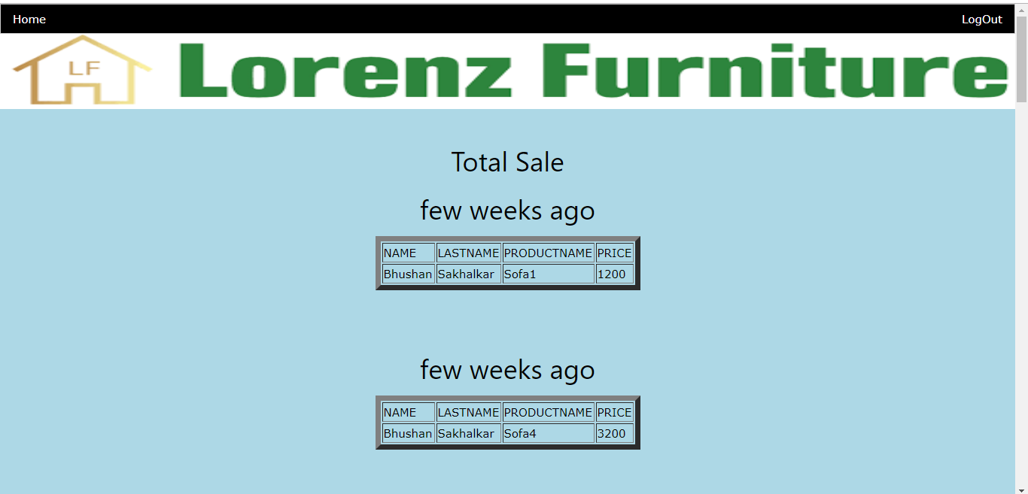

**UPDATE QUANTITY**

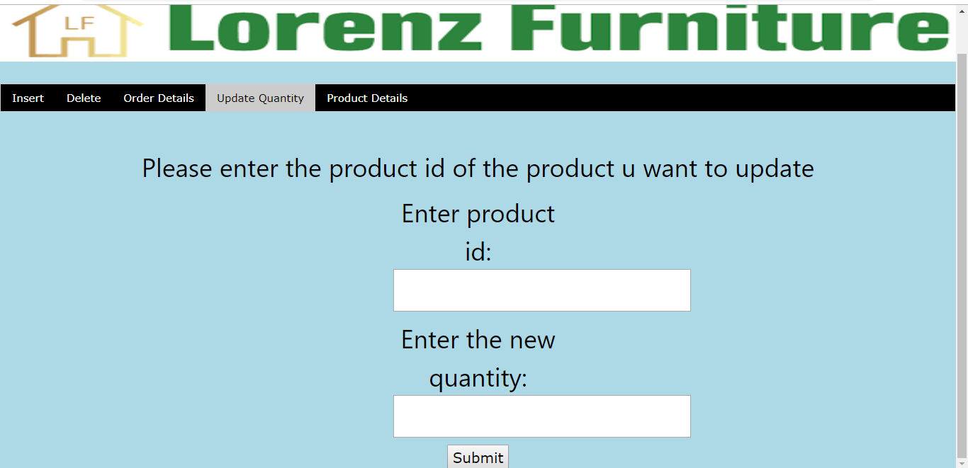

**PRODUCT DETAILS**

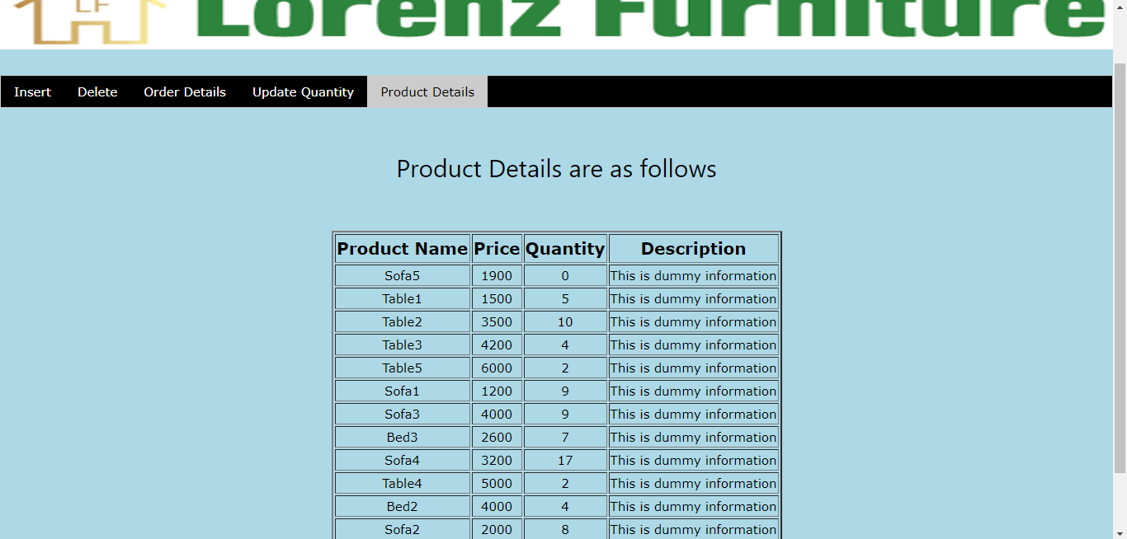

**Testing**

The next vital step of the process is testing. To check the credibility of the web application we developed, we took up the task of actually introducing people to this application.

The user-friendliness of this application was confirmed due to the ease with which the target audience could handle the application. Even a user with limited computer and development knowledge can easily work with this web application.

All the other feedbacks and additions which we received from the target audience were acted upon immediately.

The system avoids the drawbacks of the existing manual system and the validation facility of the system totally eliminates the chances of wrong data entry, which is essential for generating error free execution.

**Advantages**

The development of Online Furniture Management has led to many advantages which are:

* We can easily manage the contents of the system.
* All the furniture products are just a click away.
* Provides a path for furniture vendors to get across the globe without any intermediaries.
* The bill generation is also not done manually and is done by the application once the service amount is entered.
* Reduction of man power.
* Increased speed of work.
* Is also instrumental in storing the bill and other details of any transactions between the shopkeeper and the customers.

**Drawbacks and Limitations**

Some of the drawbacks of the created application are:

* The customers cannot delete the accounts already created on the application.
* The only payment option is cash on delivery. transferring money online is not possible.
* The option of mail is not usable.

**Future Enhancements**

The more details which can be added to this system are:

* The option to delete the existing accounts.
* Being able to pay the bill amount online.
* Being able to send the bill through mail to the customer once he has placed the order.
* Being able to send messages to the customer once new products are available

**Bibliography**

* Complete reference Java by Herbert Schildt(5th edition)
* Java 2 programming black books, Steven Horlzner
* Programming with Java , A primer ,Forth edition , By E. Balagurusamy
* Core Java Volume-I-Fundamentals, Eighth Edition, Cay S. Horstmann, Gary Cornell,
* Prentice Hall, Sun Microsystems Press
* Core Java Volume-II-Advanced Features, Eighth Edition, Cay S. Horstmann, Gary

Cornell, Prentice Hall, Sun Microsystems Press tice Hall, Sun Microsystems Press www.w3schools.com